一、Streamer System (STR-4000)
Apply fluid shear stress to cells with laminar, pulsatile or oscillating flow.
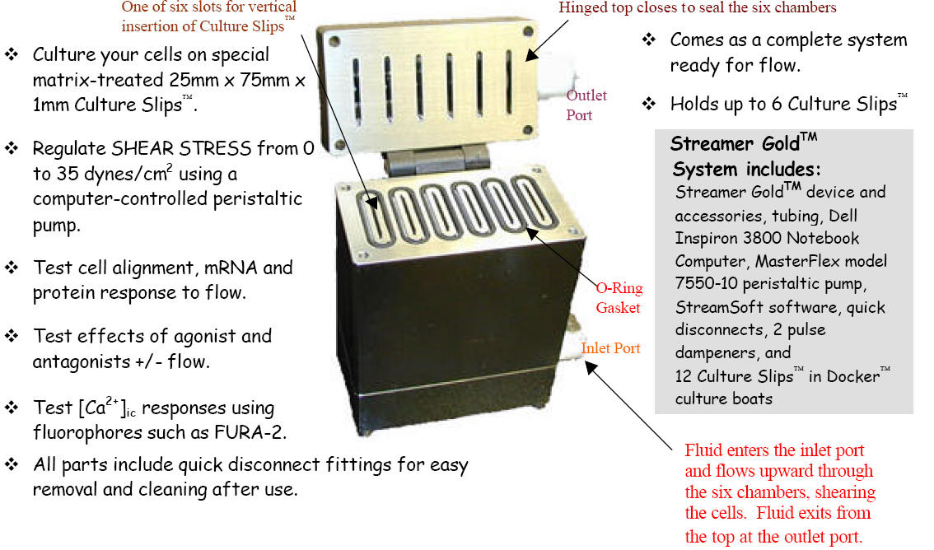
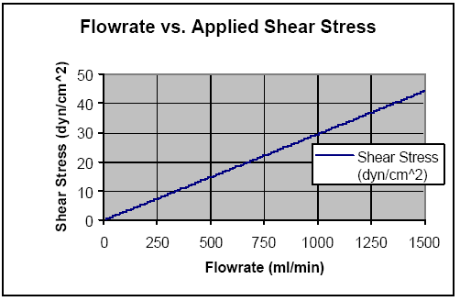
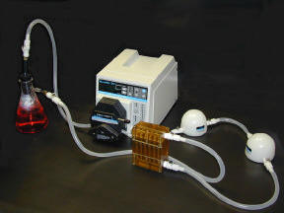
产品编号 | 简述 | 价格
STR-4000 | Streamer GoldTM System | 241472元
STR-4000C | Streamer GoldTM System  (without Dell Inspiron 3800 Computer) | 197568元
STR-4000D | Streamer GoldTM Only (without system) | 125440元
STR-4000-OFS | OsciFlow Flow Controller System | 98784元

STR-4000-OFS
Osci-Flow (STR-4000-OFS)
Provides near instantaneous fluid flow reversals. Works with Streamer and FlexFlow. Provides regulated oscillatory and pulsatile flow control via computer controlled action

二、Flexercell Tension Plus™ System _{（FX-5000）}
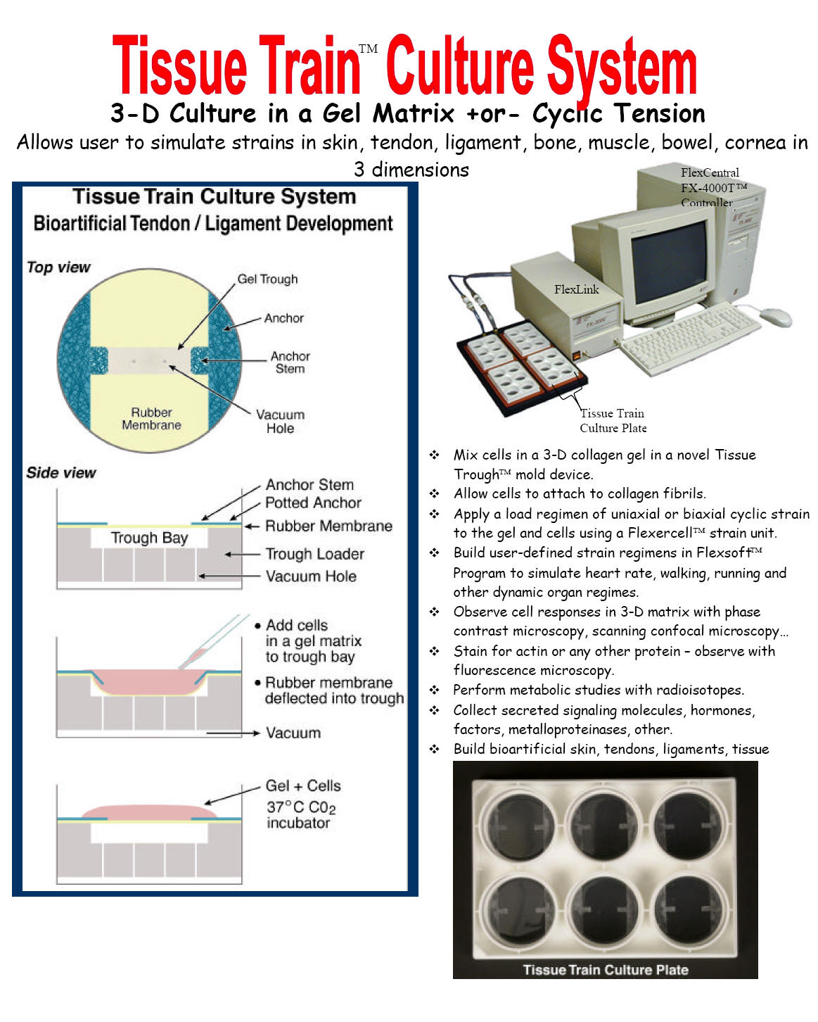
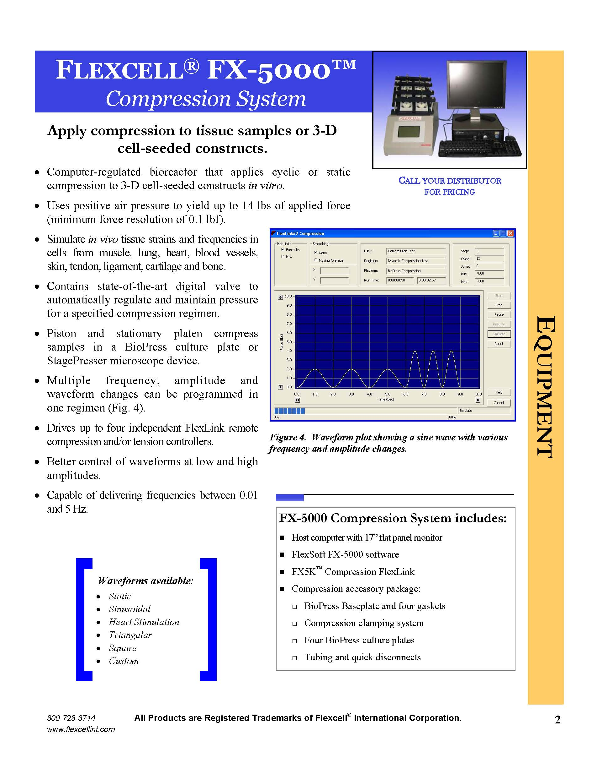
产品及价格列表：
产品编号 | 简述 | 价格
FX-5000C | Flexcell Compression System (FX-5000C)  Computer-regulated bioreactor that applies cyclic or static compression to 3-D cell-seeded constructs in vitro. | 486080元
FX-5000T | Flexcell Tension System (FX-5000T)  The FX-5000T is a computer-regulated bioreactor that applies cyclic or static tensile strains to cells cultured in vitro. Uses regulated vacuum pressure to deform cells cultured on flexible-bottomed culture plates (BioFlex, Tissue Train, and UniFlex series), producing up to 33% elongation. | 486080元
FX-5000TT | Tissue Train Culture System (FX-5000TT)  Tissue engineer 3-D cell culture in a gel matrix with or without cyclic uniaxial tension | 486080元

三、FlexFlow (FF-3000)

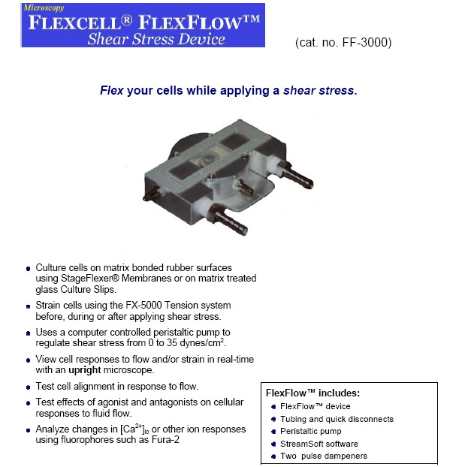

产品及价格列表：
产品编号 | 简述 | 价格
FF-3000 | FlexFlow (FF-3000)  A shear stress device that allows the user to view all responses to flow and/or strain in real-time with an upright microscope. Strain cells using the FX-5000 Tension System before, during, or after applying shear stress. | 147392元

四、FlexLink (FX-5000TFL and FX-5000CFL)

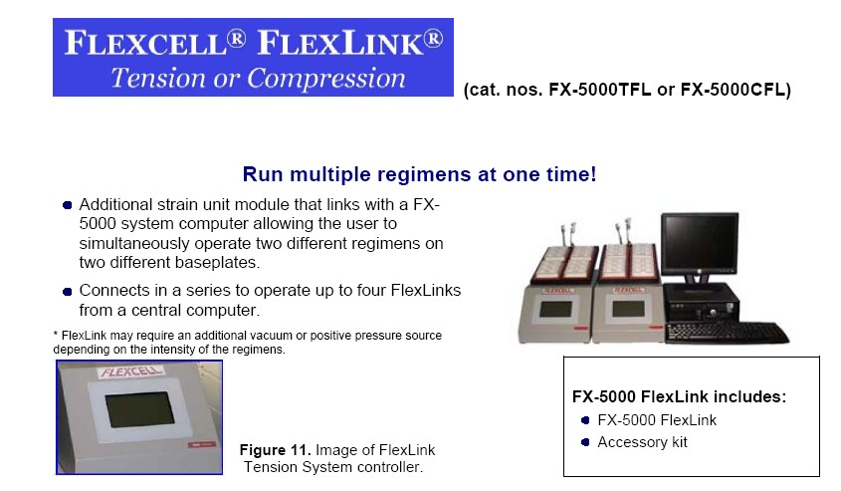

五、StageFlexer®（SF-3000）
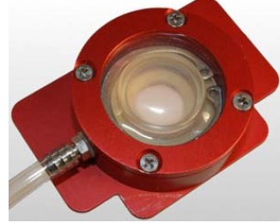
A single-well embodiment of the BioFlex® culture surface designed to allow the user to observe signaling responses to strain
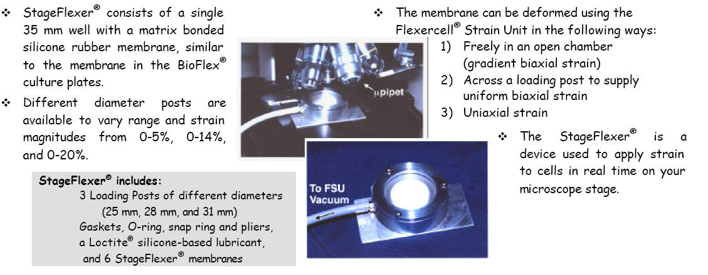
产品及价格列表：
产品编号 | 简述 | 价格
 | StageFlexer® | 15366.4元
  SF-3000

六、StagePresser Membrane（SP-3000、SPM-3000）
A single-well embodiment of the Compression PlusTM apparatus designed to allow the user
to detect signaling responses to compression
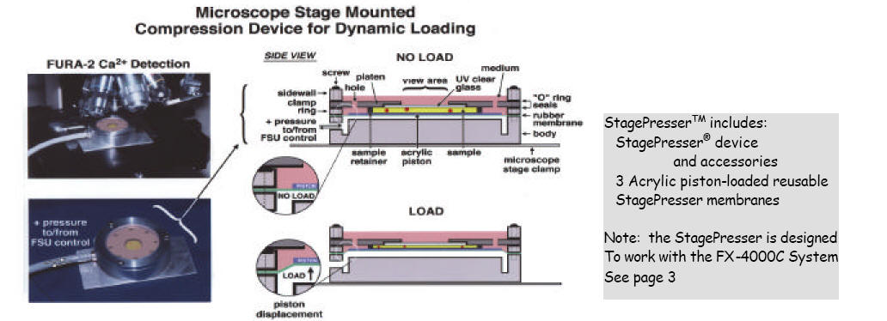
产品及价格列表：
产品编号 | 简述 | 价格
 | StageFlexer® | 16228.8元
  SP-3000
SPM-3000 | StagePresser Membrane (piston and foam retainer) | 235.2元

七、

