一、FX-5000T应力加载系统,Flexcell Tension System
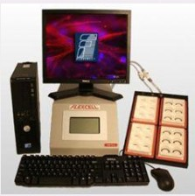

FX-5000T应力加载系统
1.技术参数:
①通过真空压力真实模拟细胞体内应力环境,使体外培养的细胞的生长状态更接近于体内环境。
②感应各种细胞在应力刺激下的生物化学反应，例如：骨骼肌细胞，肺细胞，心肌细胞，血管细胞，皮肤细胞，肌腱细胞，韧带细胞，软骨细胞和骨细胞。
③使用真空泵，抻拉培养板底部的弹性硅胶膜，细胞培养板底部最高伸展度可达到30% 。④为体外培育的细胞提供精确的，可控制的，可重复的，静态的或者周期性的应力变化。
⑤使用圆柱形或弧矩形应力加载平台提供双轴向应力或单轴向应力。不使用加载平台可以提供梯度双轴向应力(非限定性的抻拉细胞)。
⑥通过气体阀门装置可以自动调节和控制应力。
⑦同时兼容4个独立的FlexLink应力加载传导仪和/或压力加载传导仪，独立操作四个不同的实验程序。
⑧最高频率可达5 Hz。
⑨可以和BioFlex，TissueTrain，Uniflex或者Flex I细胞培养板系列一起使用。
⑩同一程序中可以运行多种频率，多种振幅和多种波形：静态波形，正弦波形，心动波形，三角波形，矩形波形和各种特制波形。

2.配置
1. FX-5000TM主机及专为Flexcell设计的DELL电脑一台
2. FX5KTM应力加载控制器一台
3. FlexSoft软件一个
4. FX5KTM 应力加载附件一套
A. 应力加载基板
B. 直径为25mm的双向应力加载平台
5. 干燥过滤器，水阱，润滑油，相关外围设备一套
6. 真空管一套
7. 双向拉力细胞培养板4个
8. 欧瑞康莱宝D8C型真空泵1台
9. 戴勒AF35压力罐1台
10. 每孔直径为24mm的6位拉力板（4个/箱）1箱
11. I型6孔拉力板（40个/箱）2箱

详细说明，见附件

二、Flexcell Compression System (FX-5000C) ，价格：￥486080元

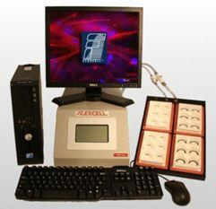 | Flexcell Tension System (FX-5000T)  The FX-5000T is a computer-regulated bioreactor that applies cyclic or static tensile strains to cells cultured in vitro. Uses regulated vacuum pressure to deform cells cultured on flexible-bottomed culture plates (BioFlex, Tissue Train, and UniFlex series), producing up to 33% elongation.  详细说明，见附件
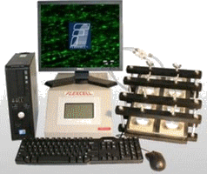 | Flexcell Compression System (FX-5000C)，￥486080元  Computer-regulated bioreactor that applies cyclic or static compression to 3-D cell-seeded constructs in vitro.  详细说明，见附件
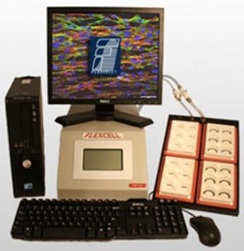 | Tissue Train Culture System (FX-5000TT) ，￥486080元  Tissue engineer 3-D cell culture in a gel matrix with or without cyclic uniaxial tension.  详细说明，见附件
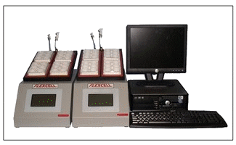 | FlexLink (FX-5000TFL and FX-5000CFL)  The FlexLink is a remote strain unit module that works in conjunction with the FX-5000T and/or FX-5000C to allow the user to simultaneously run two different regimens on two different baseplates.  详细说明，见附件
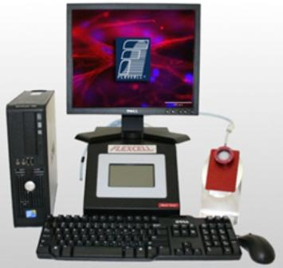 | Flexcell Flex Jr. Tension System，￥486080元  Apply equibiaxial or uniaxial tension to cells in microscope devices. Computer-regulated bioreactor that applies cyclic or static tensile strains to cells cultured in vitro. Developed to use with SF-3000, SF-4000, and FF-3000 (not included)  详细说明，见附件
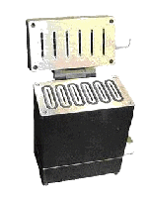 | Streamer System (STR-4000) ，￥241472元  Fluid Shear Stress Device  Apply fluid shear stress to cells with laminar, pulsatile or oscillating flow.  详细说明，见附件
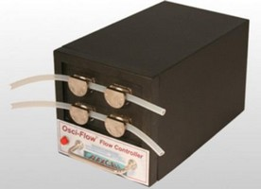 | Osci-Flow (STR-4000-OFS) ，￥98784元  Provides near instantaneous fluid flow reversals. Works with Streamer and FlexFlow. Provides regulated oscillatory and pulsatile flow control via computer controlled action.  详细说明，见附件
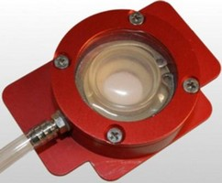 | StageFlexer (SF-3000) ，￥ 元  A single-well embodiment of the BioFlex culture plate designed to allow the user to observe cellular responses to cyclic or static tension in real-time.  详细说明，见附件
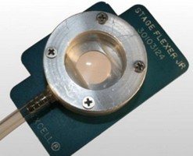 | StageFlexer Jr. (SF-4000) ，￥ 元  Consists of a single one inch well designed to accept a membrane removed from a BioFlex, UniFlex or TissueTrain plate. The user can continue to strain cells while observing responses in real-time on a microscope stage.  详细说明，见附件
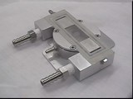 | FlexFlow (FF-3000) ，￥ 元  A shear stress device that allows the user to view all responses to flow and/or strain in real-time with an upright microscope. Strain cells using the FX-5000 Tension System before, during, or after applying shear stress.  详细说明，见附件
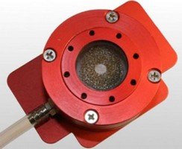 | StagePresser (SP-3000) ，￥ 元  A single-well embodiment of the Compression apparatus designed to allow the user to view compressed cells in real-time with an upright microscope.  详细说明，见附件
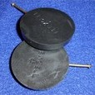 | FlexStop (BFS-3000) ，￥ 元  Don't stretch all your cells at once! Use FlexStops to block stretching.  详细说明，见附件
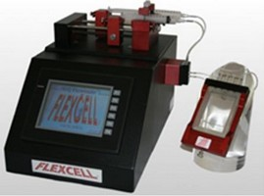 | HiQ Flowmate - Fluid Control System  Accurate and precise flow modes (constant steady flow, pulsatile flow, continuous flow, ramp flow, oscillating flow) for fluid shear stress tests. Micro and nanofluidics. Diluting, dispensing, and injecting applications. Animal drug infusion or fluid withdrawal. Mixing and proportioning fluids.  详细说明，见附件
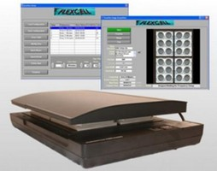 | ScanFlex ，￥ 元  Measure gel compaction in 3-D bioartificial tissues.  详细说明，见附件

